 | BAHRIA UNIVERSITY,  (Karachi Campus)  Department of Software Engineering  ASSIGNMENT#02 – Spring 2025

COURSE TITLE: | Data Encryption and Security | COURSE | CODE: CEN-451
Class: | BSE – 8A&B | Shift: | Morning
Course Instructor: | Dr. Osama Rehman | Date: | 12-May-2025
Due Date:  Name:  Section BSE 8B | 19-May-2025  Muhammad Shoaib Akhter Qadri | Marks:  Enrollment No:  Reg No: | 7.0 Marks  02-131212-009  79290
Instructions:
- Question#1 & 2 are “Complex Engineering Problems (CEP)” having the attribute of no obvious solution.
- This is an individual effort task.
- Write your full name, registration number and section on the title page.

Q1. While using Google Chrome as the web-browsing tool, extract the information required as indicated below from the “Digital Certificates” of any two websites of your own choice. Prepare separate tables for each chosen website. [CLO#5, CEP, 4.0 marks]

Website: https://blognetwork.live

S# | Parameter | Answer
1 | Google Chrome Version | 136.0.7103.114 (Official Build) (64-bit)
2 | Website URL | https://blognetwork.live
3 | Issued to Common Name (CN) | blognetwork.live
4 | Issued by Common Name (CN) | E6
5 | Issued On | Wednesday 19 March 2025 at 21:03:45
6 | Expires On | Tuesday 17 June 2025 at 21:03:44
7 | Subject Public Key Algorithm | Elliptic Curve Public Key
8 | Subject Public Key Value | 00 04 D9 0D 6C F1 41 24 9B BD FA 77 F6 29 0F A3 8B B4 24 25 D9 C8 EF E5 58 07 8B 67 9E 9A 0E 6C A6 BF CA BC 28 86 32 2A 16 E3 13 E1 19 07 97 D5 BE 57 96 8D FC 10 34 CF CB E2 D3 17 47 57 07 A6 32 55 EC DD DD 0A 10 3C 0F 6A BC 35 7B 6C EF 9F D9 3B 44 E3 82 4D B7 DF 3F E5 5B 34 42 B2 66 91 B0 0C
9 | Public Key Length (bits) | 256
10 | Public Key Length (decimal) | 256
11 | Hash Function Algorithm | X9.62 ECDSA Signature with SHA-384
12 | Device Name / ID (From Computer) | VivoBook

Website: https://universalblog.live

S# | Parameter | Answer
1 | Google Chrome Version | 136.0.7103.114 (Official Build) (64-bit)
2 | Website URL | https://universalblog.live
3 | Issued to Common Name (CN) | universalblog.live
4 | Issued by Common Name (CN) | R11
5 | Issued On | Wednesday 23 April 2025 at 09:04:18
6 | Expires On | Tuesday 22 July 2025 at 09:04:17
7 | Subject Public Key Algorithm | PKCS #1 RSA Encryption
8 | Subject Public Key Value | Modulus (2048 bits):  C9 C1 D0 EB 49 33 2F 20 1B 0E 1F 4B AD 3B D4 D2 C6 97 D3 B5 78 DD 59 C4 04 11 93 79 45 B5 5E F8 50 64 27 9D 40 9D 58 85 48 3D E2 A4 FA E9 1B 36 5B DD 0F 27 78 99 24 19 22 49 B2 09 1C 87 8B 65 72 94 9F E0 A3 3D EA C0 3B 8E F4 F6 55 32 D5 20 FC 52 88 59 C7 99 EC AF 68 F3 59 88 FE EE A9 C3 B9 9F 94 AF ED D1 4A 9F 42 B0 DB 24 88 34 2F E6 90 78 C8 40 6D 3E 7B 32 E2 53 E2 B2 95 BE AC 8A 84 6D FC 8D 56 52 E7 38 01 A3 83 7F B4 05 D2 C4 37 FA A7 C2 5E 8C 26 74 83 69 77 D4 46 F9 D1 79 47 F3 61 77 11 40 E1 71 10 9B 04 3C 69 51 57 03 40 BD 9D A6 4B F0 B2 39 7A 90 9F B4 4D 46 72 DE 9C 08 87 2E 2C 3F 21 53 45 8E B9 EA D3 65 FE C5 DC 51 49 E2 47 78 52 54 19 B4 43 FD F8 E1 FE D3 53 A4 74 51 84 6E 41 B7 6E 3F E1 89 55 A9 1B 7F 3C 01 4C 0B 98 3F D0 B3 53 2B 22 87 38 40 E2 05 Public Exponent (17 bits): 01 00 01
9 | Public Key Length (bits) | 2048
10 | Public Key Length (decimal) | 2048
11 | Hash Function Algorithm | PKCS #1 SHA-256 With RSA Encryption
12 | Device Name / ID (From Computer) | VivoBook

Q2. Choosing one of the websites selected in (Q1), Export its certificate into your device and get it installed into your “current user” account and while using “automatic” selection of location based on certificate type. Once installed, locate where the certificate is installed using Windows “certificate manager”. Provide snapshots of the whole process conducted along with snapshot of the location in which the certificate is installed. [CLO#3, CEP, 3.0 marks]

Website: https://blognetwork.live:

Step 1:
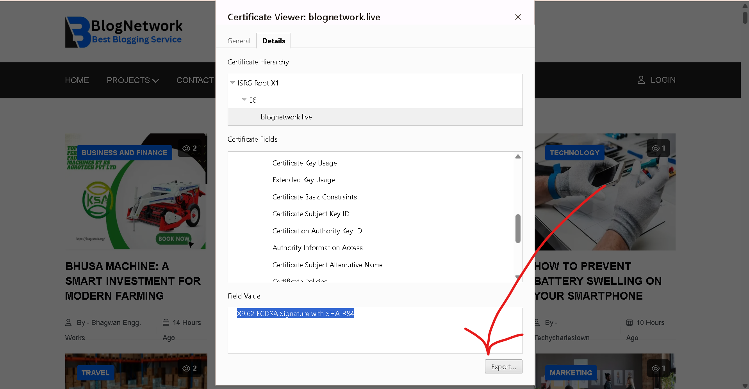

Step 2:
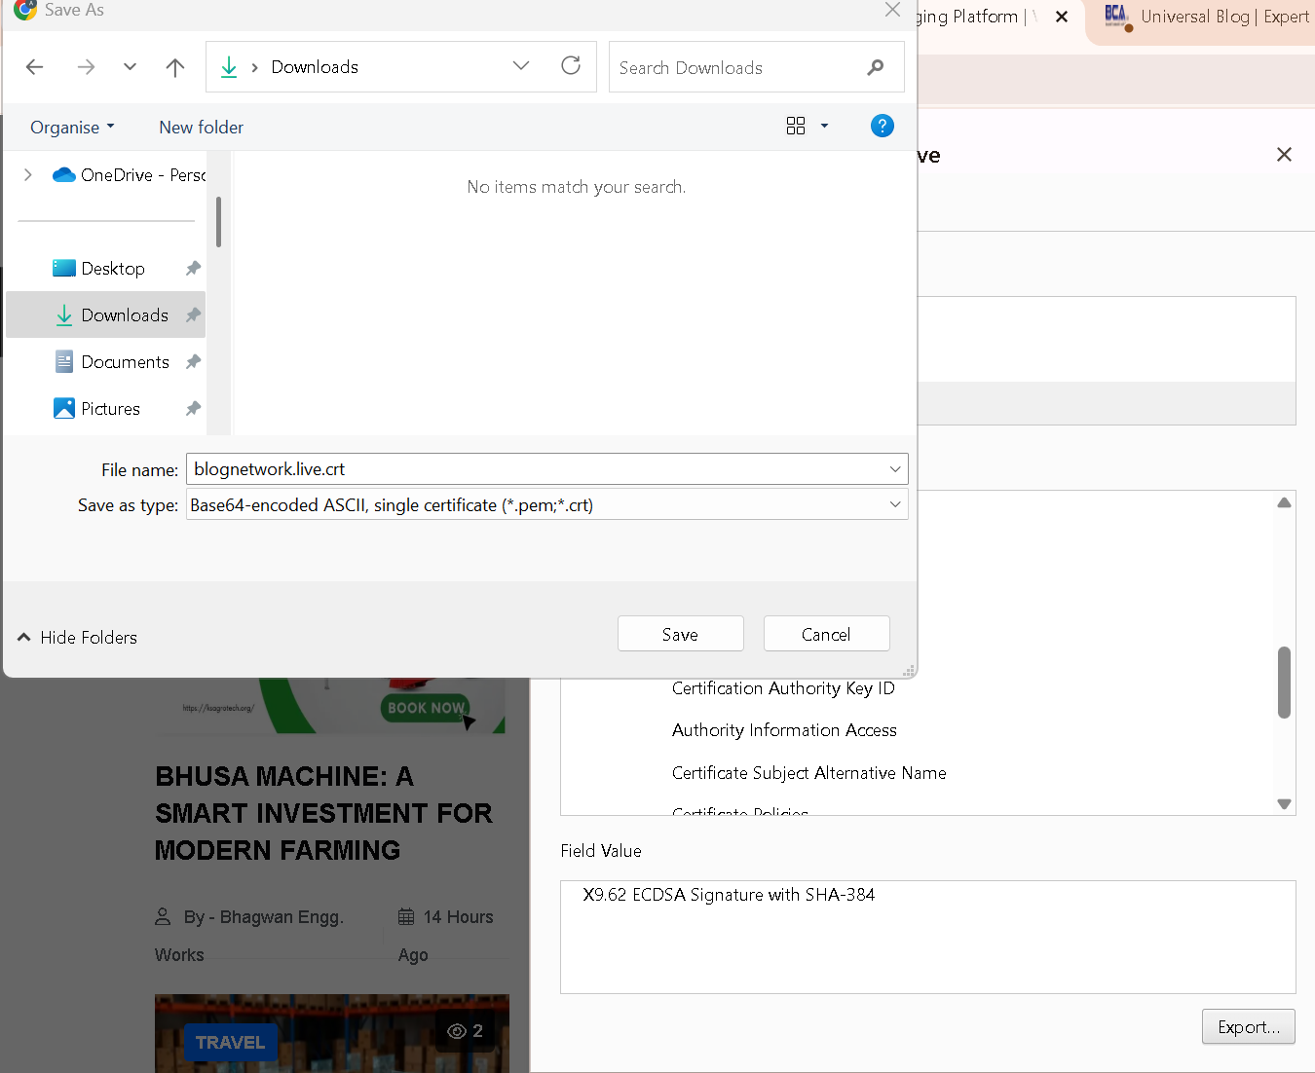

Step 3:

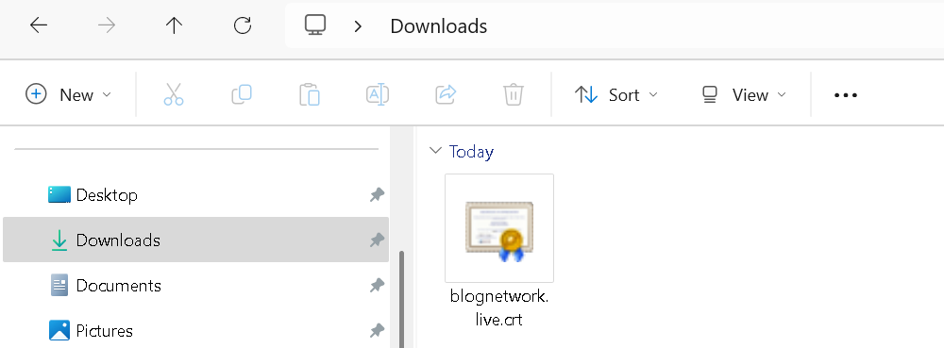

Step 4:

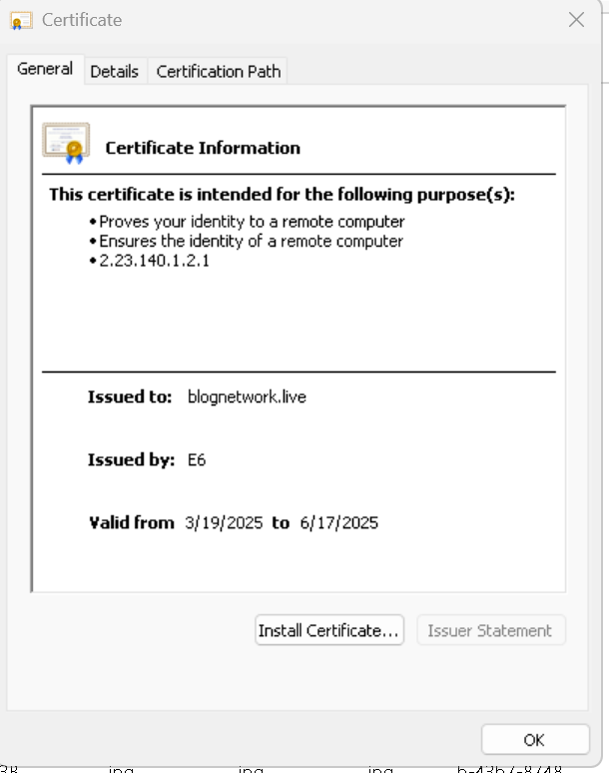

Step 5:

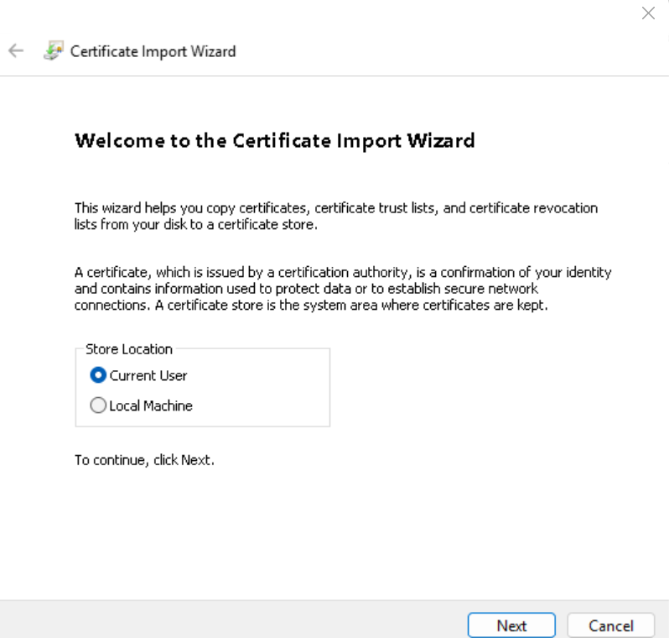

Step 6:

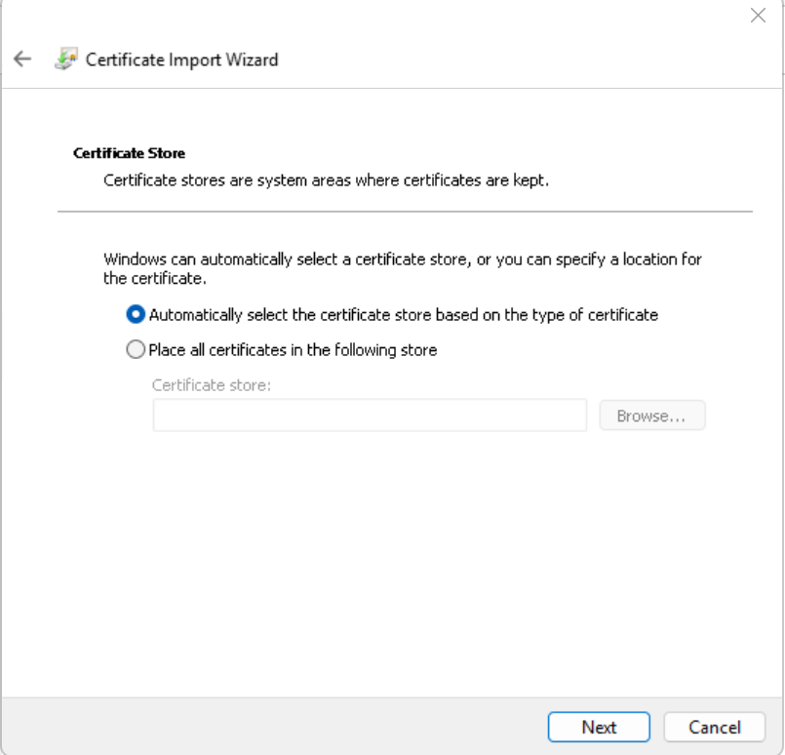

Step 7:

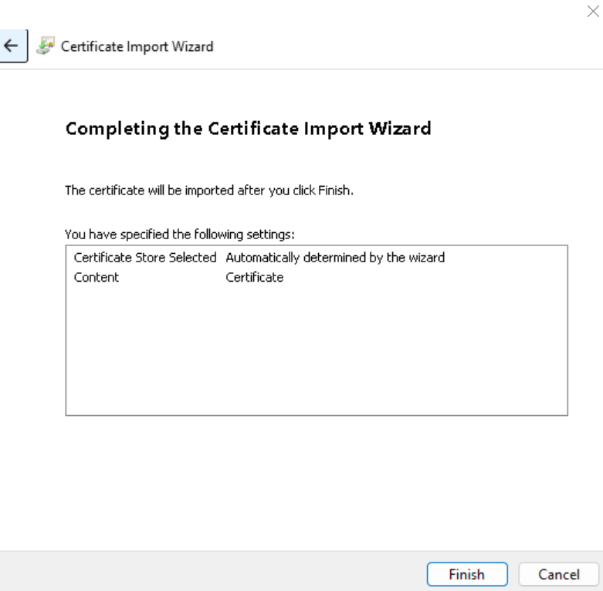

Step 8:

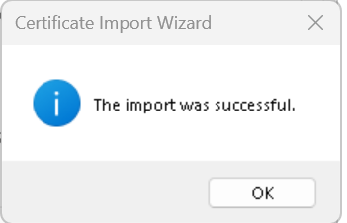

Step 9:

